Speed/Cruise Control Dedicated RTT w/Adaptive Cruise – CGEA 1.3

Functional Description

The Speed/Cruise Control Dedicated RTT is intended for use in instrument clusters with a 4.2" LCD or similar display with a dedicated location for this RTT; it is not intended for use on instrument clusters with a B-display.

The purpose of the Speed/Cruise Control Dedicated RTT is to inform the driver that the speed control system has been engaged and is actively providing speed control for the vehicle, as well as show set speed.

This STSS works in conjunction with the Collision Avoidance & Driver Support Instrument Cluster Interface Specification (referred to as “CADS spec”). The CADS spec. handles the case when Adaptive_Cruise_Cfg is Enabled. This STSS handles when Adaptive_Cruise_Cfg is Disabled.

The Speed/Cruise Control Dedicated RTT correlates the CcStat_D_Actl signal, the CcOvrrdActv_B_Actl signal, the Veh_V_DsplyCcSet signal, the Adaptive_Cruise_Cfg bit and the Operational_Mode to illuminate or extinguish the Speed/Cruise Control Dedicated RTT and set speed.

Programs that have the Speed Control RTT in a display area should use this STSS module for the Speed/Cruise Control Dedicated RTT. Programs with only a telltale (and no set speed display for this feature) should refer to Speed Control Telltale STSS. At this time, all clusters from Level 0 to Level 3 should use this STSS.

Interfaces

Interface Context Diagram (I/O Block Diagram)
Figure 1 Speed/Cruise Dedicated RTT Interface Context Diagram
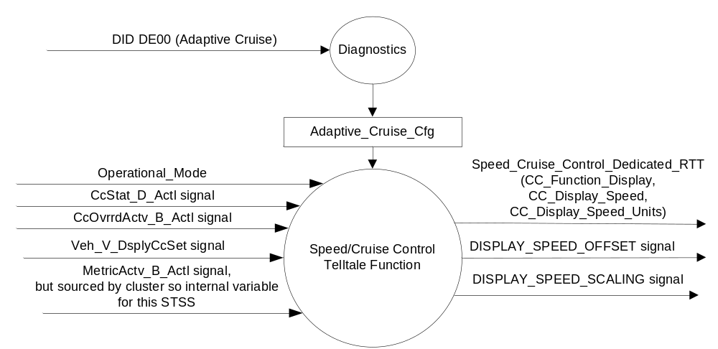

Inputs

      - INTERNAL:
            - Operational_Mode
            - MetricActv_B_Actl signal (see Display Unit Selection Control Function STSS)
            - Adaptive_Cruise_Cfg
      - MUX message on the CAN Bus from the PCM

- Cruise Control Signals

Signal Name | Size (bits) | Detail | Units | Res. | Offset | State Encoded | Min | Max
CcStat_D_Actl | 3 |  | SED | 1 | 0 |  | 0  (0x0) | 7 (0x7)
CcStat_D_Actl |  | Off |  |  |  | 0x0
CcStat_D_Actl |  | Denied |  |  |  | 0x1
CcStat_D_Actl |  | Standby_Denied |  |  |  | 0x2
CcStat_D_Actl |  | Standby |  |  |  | 0x3
CcStat_D_Actl |  | Active_Que_Assist |  |  |  | 0x4
CcStat_D_Actl |  | Active |  |  |  | 0x5
CcStat_D_Actl |  | Undefined |  |  |  | 0x6
CcStat_D_Actl |  | Undefined |  |  |  | 0x7
CcOvrrdActv_B_Actl | 1 |  | SED | 1 | 0 |  | 0  (0x0) | 1 (0x1)
 |  | Deactivate |  |  |  | 0x0
 |  | Activate |  |  |  | 0x1
Veh_V_DsplyCcSet | 8 |  | Unitless | 1 | 0 |  | 0  (0x0) | 253 (0xFD)
 |  | Unknown |  |  |  | 0xFE
 |  | Fault |  |  |  | 0xFF

Outputs
- Speed_Cruise_Control_Dedicated_RTT, which is used to control the state of the Reconfigurable Telltale
- MUX Signals on the CAN bus. The 2 output signals are defined in the CADS Cluster Interface Specification. They are referenced here because the PCM/ECM uses the same signal as the ACC (Adaptive Cruise Control) interface to determine displayed limit speed.

- DISPLAY_SPEED_OFFSET Signal
Signal Name | Size (bits) | Detail | Units | Res. | Offset | State Encoded | Min | Max
DISPLAY_SPEED_OFFSET | 3 |  | KPH | 0.5 | 0 |  | 0  (0x0) | 3.5 (0x7)

- DISPLAY_SPEED_SCALING Signal
Signal Name | Size (bits) | Detail | Units | Res. | Offset | State Encoded | Min | Max
DISPLAY_SPEED_SCALING | 4 |  | % | 0.5 | 100 |  | 100  (0x0) | 107.5 (0xF)

Function/Performance

Operational Modes

Mode | Differentiating Vehicle Conditions
Sleep Mode | Speed/Cruise Control Dedicated RTT OFF
Limited Mode | Speed/Cruise Control Dedicated RTT OFF
Normal Mode | Speed/Cruise Control Dedicated RTT ON / OFF
Crank Mode | Speed/Cruise Control Dedicated RTT ON / OFF

The above table references the setting of the RTT flag as per this section. However, the actual RTT display operational modes are displayed in the Message Center section of this SPSS.

Voltage Levels

Refer to the Cluster Features table located in Operational Modes and Voltage Range Strategies Section in this SPSS.

Human-Machine Interface

Visual

Indicator Graphics / Display Format



For actual symbol definition see pixel definition section in the message center section. The pixel representation is based upon the symbol definition database # J.08 of the 03-0685 ARL requirement.

Indicator Color Coordinates

Green - Reference SDS IL-0017/IS-0379

Indicator Characteristics

Sample M0 graphics:

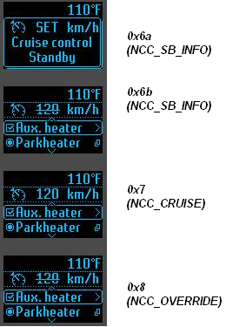
Note that state 0x6b (NCC_SB_INFO) still uses strikethrough font for Level 0, but HMI could use grayscale instead. Follow HMI provided.

Sample M1 graphics:

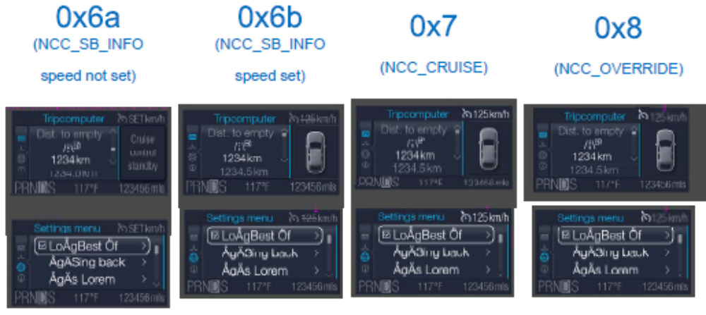
Note that state 0x6b (NCC_SB_INFO) no longer uses strikethrough font for Level 1 (graphic above not correct). Follow HMI provided.

Sample M2 graphics:
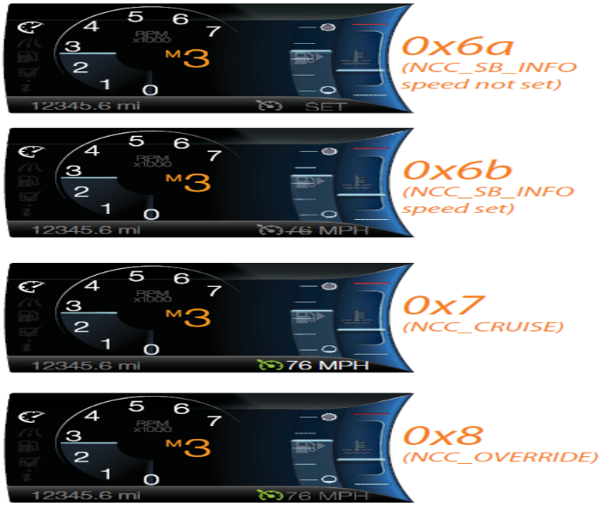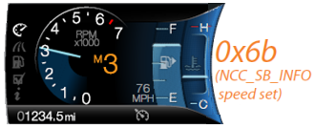

Audio

None.

System Accuracy

The Speed_Cruise_Control_Dedicated_RTT shall change the state of the RTT within 100msec of a state change as indicated in the state matrix reference 1.3.5.1 Subsystem Algorithm Flowchart/ State Diagram

Operation: Performance and Functional

Subsystem Algorithm Flowchart / State Diagram

Figure 2 Speed/Cruise Dedicated RTT Diagnostic Configuration Flowchart

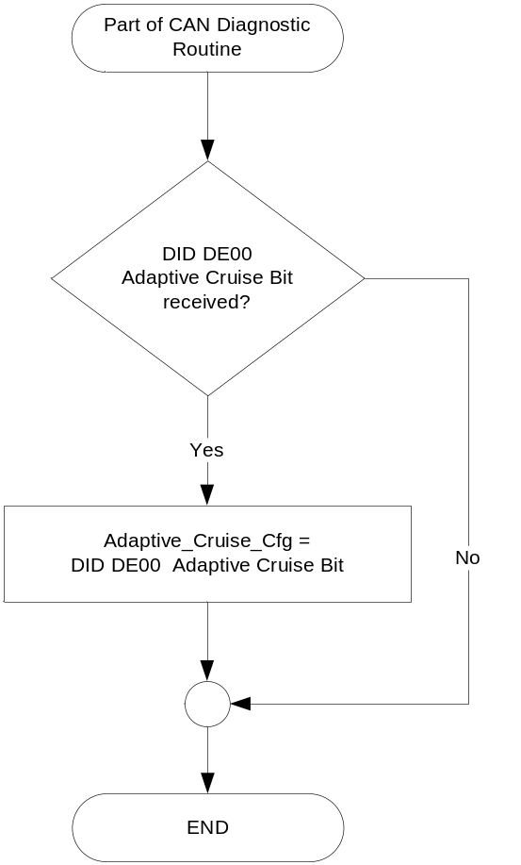

- State matrix for Speed/Cruise Control Dedicated RTT

Operational_Mode | Adaptive_  Cruise_Cfg | CcStat_D_Actl | CcOvrrdActv_B_Actl | MetricActv_B_Actl | Veh_V_  DsplyCcSet* | CC_Function_  Display | CC_Display_  Speed | CC_Display_  Speed_Units
Normal or Crank | Disabled (0x0) | Standby Denied (0x2)  OR  Standby (0x3) | X | X | 0 | NCC_SB_INFO | SET | Inactive
 |  |  |  | Metric (0x1) | >0 | NCC_SB_INFO | STRIKE** | Metric
 |  |  |  | English (0x0) | >0 | NCC_SB_INFO | STRIKE** | English
Normal or Crank | Disabled (0x0) | Active_  Que_Assist (0x4)  OR  Active (0x5) | Deactivate (0x0) | X | 0 | NCC_CRUISE | Inactive | Inactive
 |  |  |  | Metric (0x1) | >0 | NCC_CRUISE | ACT | Metric
 |  |  |  | English (0x0) | >0 | NCC_CRUISE | ACT | English
Normal or Crank | Disabled (0x0) | Active_  Que_Assist (0x4)  OR  Active (0x5) | Activate (0x1) | X | 0 | NCC_OVERRIDE | Inactive | Inactive
 |  |  |  | Metric (0x1) | >0 | NCC_OVERRIDE | STRIKE** | Metric
 |  |  |  | English (0x0) | >0 | NCC_OVERRIDE | STRIKE** | English
Normal or Crank | Enabled (0x1) | As per CADS Specification, Table 1 and Table 2 |  |  |  | As per CADS Specification
All other cases |  |  |  |  |  | Inactive | Inactive | Inactive

X=Don’t Care
*The embedded states conditions, Veh_V_DsplyCcSet = 'Unknown' and Veh_V_DsplyCcSet = 'Fault', shall be mapped to Veh_V_DsplyCcSet = 0 for use in Table 1.3.
** Level 0 will use either strikethrough font or grayscale. Levels 1,2,3 will NOT use strikethrough. Follow HMI provided.

Operation Description (supports algorithm flowchart /state diagram)

Speed_Cruise_Control_Dedicated_RTT shall extinguish when transitioning from Sleep or Limited to Normal or Crank until receipt of the CcStat_D_Actl CAN Signal.

Function Safety Classification (EMC)

B

Memory Storage

Parameter Name | Description | Value at  Battery Connect | Value at  Module Wake-up
Speed_Cruise_Control_Dedicated_RTT | Used to control the state of the display. This is broken into CC_Function_Display, CC_Display_Speed, CC_Display_Speed_Units. Reference CADS Specification (Collision Avoidance & Driver Support Instrument Cluster Interface Specification) for definitions. | Inactive (OFF) | Inactive (OFF)
CcStat_D_Actl CAN Signal | CAN signal sent from the PCM | OFF (0x0) | Do Not Init
DISPLAY_SPEED_OFFSET Signal | Output signal transmitted by the cluster | Refer to CADS spec | Refer to CADS spec
DISPLAY_SPEED_SCALING Signal | Output signal transmitted by the cluster | Refer to CADS spec | Refer to CADS spec
MetricActv_B_Actl Signal | Output signal transmitted by the cluster. Defined in Display Unit Selection Control Function STSS. | Refer to CADS spec | Refer to CADS spec
Operational_Mode | 4 state indicator for cluster operational mode | Limited | Limited, Normal or Crank
Adaptive_Cruise_Cfg | State Indicator for feature presence controlled via CAN at EOL at VO plant. Defaulted to NOT PRESENT at supplier manufacturing. | Use Stored Value | Use Stored Value

Prove Out

None

Reconfigurable Telltale

No, dedicated area.

Message Center Msg

See Message Center Function

Error Handling

Missing Message Strategy

The signals will be declared missing as per the Diagnostics section of this SPSS.

DTCs states and history will be determined as per the Diagnostics section of this SPSS.

Diagnostics

Self Test

Bulb illuminated during self test as per Self_Entry_Bulb_Check_Timer

Engineering Test Mode

Reference section “Dealer / Engineering Test Mode (ETM)”

Part II Performance

Supported Diagnostic Trouble Codes (DTCs)
DTCs shall be logged as per the diagnostic section of this SPSS*.

DTC | Description | When Logged
C10000 | Lost communication with ECM/PCM | Message missing for more than 5 seconds
C40182 | Invalid Data received from ECM/PCM - No Update | When the _UB signal value = 0 for more than 5 seconds
* If the missed signal has an _UB signal, the NO Update DTC is to be logged.
Otherwise, the Lost Communication DTC is logged.

DID DE00
Block  Num | Block Description | Byte(s) | Bits | State: Description | "0" | "1" | Default | Comments/Information
PACKETED BLOCKS
$00 | Option Content (B&A) | * | * | Adaptive Cruise | Disabled | Enabled | Disabled
*Byte and bit location to be identified in Part II Specification for this cluster

Reference Specification

CR-0030 Adaptive Cruise Control Driver Interface

SC-0190 Speed Control Telltale

IS-0001 WARNINGS/INDICATORS/DISPLAYS PROVEOUT
IS-0046 INSTRUMENTATION MATERIAL RESISTANCE TO CLEANING
IS-0052 OPERATING VOLTAGES - FUNCTIONAL/PERFORMANCE
IS-0069 FUNCTIONAL IMPORTANCE CLASS
IS-0324 WINDSHIELD & OTHER REFLECTIONS
IS-0327 WARNING INDICATOR EVALUATION
IS-0329 FLICKERING OF LAMPS
IS-0379 NORTH AMERICAN WARNINGS AND INDICATORS STRATEGY

IL-0017 TELLTALE AND INTERIOR ILLUMINATION COLOR
IL-0021 CRAFTSMANSHIP - DISPLAYS
IL-0023 CLARITY/LEGIBILITY/READABILITY
IL-0025 INTERIOR ILLUMINATION INTENSITY
IL -0027 VISUAL CONTRAST
IL -0043 OPERATIONAL ENVIRONMENT FUNCTIONALITY
IL -0045 COLOR
IL -0047 TELLTALE; INDICATOR AND DISPLAY LIGHT INTENSITY
IL -0048 ILLUMINATION ACCEPTABILITY

03-0661 PLACEMENT: CONTROL AND DISPLAY LOCATIONS
03-0662 PLACEMENT: LOGICAL GROUPING FUNCTION AND USAGE
03-0664 PLACEMENT: DOWN VISION TO COMPONENTS WITH HIGH VISUAL DEMAND
03-0665 PLACEMENT: EXPECTED LOCATIONS OF CONTROLS AND DISPLAYS VDS
03-0670 INTERIOR VISIBILITY
03-0671 INTERIOR VISIBILITY: REFLECTIONS FROM COMPONENTS & SURFACES
03-0672 INTERIOR VISIBILITY: REFLECTIONS IN DISPLAYS
03-0673 INTERIOR VISIBILITY: VISUAL OBSCURATIONS
03-0674 INTERIOR VISIBILITY: ILLUMINATION CONTROLS / DISPLAYS
03-0675 INTERIOR VISIBILITY: VEILING GLARE
03-0677 INTERIOR VISIBILITY: SUNLIGHT WASHOUT
03-0681 IDENTIFICATION: CHARACTER AND SYMBOL SIZE
03-0682 IDENTIFICATION: LEGIBILITY
03-0685 IDENTIFICATION: SYMBOLS, ABBREV FOR CONTROL
03-0721 LOGIC OF OPERATION: OPERATIONAL STEREOTYPES
03-0722 LOGIC OF OPERATION: INTERPRETATION
03-0723 LOGIC OF OPERATION: USE OF SYSTEMS WITH VISUAL DISPLAYS

Revision History
SPSS Module Revision History
Revision Level | Name | Change Description | Date
1.0 | V. Patel | Updated for CGEA 1.3 based on CGEA STSS v1.0  Section 1.2.2 – Removed table referencing the HS-CAN message that contains the input signals.  Section 1.4 – Rewritten. Deleted references of specific missing message flags and timer.  Section 1.5.3 – Deleted DTC logging criteria from the table. | 4/12/2010
2.0 | S. Watkins | Updated to match major changes from CGEA STSS v2.0:  Major re-write to work with the CADS specification (Collision Avoidance & Driver Support Instrument Cluster Interface Specification). Every section updated.  Previous direction had been to only show an RTT for Normal Cruise Control (NCC). However, 2011 U38x/U502 launched showing set speed as well. Global direction is now to show set speed. Thus, when Adaptive_Cruise_Cfg is DE00 configured to Disabled (0x0), the cluster shall support the 4 NCC states from the CADS specification (NCC_SB_INFO – speed NOT set, NCC_SB_INFO – speed set, NCC_CRUISE, NCC_OVERRIDE).  Additional changes form CGEA version:  - Section 1.3.5.1, Table 1.3 – Added Standy_Denied and Active_Que_Assist to table. | 2/11/2011
2.1 | S. Watkins | CGEA1.3 CADS Cluster Interface Specification – ver 010 modified the displayed graphic for state 0x6b (NCC_SB_INFO) to remove the strikethrough. This is appplicable to all CGEA 1.3 vehicles. However, it is only applicable to level 1,2, and 3 clusters at this time. Level 0 has kept the strikethrough, although they may elect to attempt gray scale in the future.  - Section 1.3.3.2.2 – Updated or made comments to sample graphics for 0x6b (NCC_SB_INFO).  - Section 1.3.5.1 – Table 1.3 – Changed “STRIKE” in rows 2 and 3 to “STRIKE**” and added footnote below table. | 4/30/2013
2.2 | S. Watkins  M. Hakim | Removed specifying the HS CAN bus throughout the document.  Section 1.2.1, Figure 1, and Section 1.5.3: Updated DE00 to DExx.  Section 1.2.2, Table 1.0: Removed the ID column and the Pos. column for the CAN signals table.  Section 1.3.5.1: Added Figure 2 for “Speed/Cruise Dedicated RTT Diagnostic Configuration Flowchart”.  Section 1.5.3: Added the Invalid Data – No Update DTC, and the criteria for logging Lost Communication or No Update DTC.  Updated document footer. | 8/9/2013
2.3 | A. Venuturupalli  S. Watkins | Updated CC_Display_Speed as STRIKE** for NCC_OVERRIDE states in Table 1.3 (per Denso P558 MY17 Q&A #570) | 3/25/2015
2.4 | Deepa  S. Watkins | No functional changes, only cleaned up typos:  - Spec updated as per QnA IPC_FS550_MY15 #39 (Value ofCcOvrrdActv_B_Actl is defined as Cruise_Req_Not_Overridden /Cruise_Overridden in Table 1.0, and as False /True in Table 1.3). Corrected Table 1.3 and Table 1.0 to match CAN signal, which is Deactivate/Activate.  - Updated Table 1.3 to show functionality in Crank | 10/2/2016

